Draft Paper

**Cryptocurrency Price Prediction Model Using LSTM and GRU**

**Abstract:**

Cryptocurrencies have emerged as a new asset class, presenting an opportunity for extensive research due to their volatility and dynamic nature. This paper proposes the use of three types of recurrent neural network (RNN) algorithms, namely GRU and LSTM to predict the price of cryptocurrency: Bitcoin (BTC)). The models demonstrate excellent predictive performance, with the GRU algorithm outperforming LSTM in all cases. Specifically, GRU yields the most accurate predictions for LTC, with mean absolute percentage error (MAPE) percentages of 0.2454%.On the other hand, produces the lowest prediction accuracy, with MAPE percentages of 5.990%.The models presented in this paper offer accurate price predictions, which can have significant economic implications by aiding investors and traders in making informed decisions regarding cryptocurrency transactions.

**Introduction:**

The cryptocurrency market has garnered significant attention in recent years, characterized by its high volatility and potential for substantial returns. Accurate prediction of cryptocurrency prices is crucial for investors and traders to make informed decisions. However, the inherent complexity and uncertainty of the market pose challenges for traditional forecasting methods. In this study, we aim to develop a machine learning model capable of predicting cryptocurrency prices with high accuracy. By leveraging historical price data and employing advanced machine learning techniques, we seek to provide valuable insights into this dynamic market

**Literature Review:**

The literature review provides an overview of various studies focused on predicting cryptocurrency prices using machine learning algorithms and artificial intelligence approaches. The advantages of machine learning models over traditional forecasting models are highlighted, emphasizing their ability to improve accuracy and deliver results similar to actual market outcomes.

Several studies have explored the application of different machine learning algorithms, such as neural networks, support vector machines, and deep learning, for cryptocurrency price prediction. These studies demonstrate the effectiveness of machine learning ensemble techniques, random forests, stochastic gradient boosting machines, and hybrid models combining LSTM and GRU for accurate price forecasts.

The importance of incorporating cryptocurrencies into investment portfolios is discussed, with findings indicating that appropriate cryptocurrency allocation can reduce risk and provide investors with additional allocation options. The recommended allocation ranges from 5% to 20%, depending on the investor's risk tolerance.

Furthermore, the literature review covers the use of various machine learning methods, including artificial neural networks, support vector machines, and random forests, for predicting the values of specific cryptocurrencies such as Bitcoin. The studies highlight the high accuracy achieved by these models and their potential for forecasting prices.

Additionally, the review explores the role of social factors, sentiment analysis. Studies comparing different models, such as ARIMA, LSTM, and GRU, indicate that each model has its strengths, with ARIMA performing well in terms of accuracy.

Overall, the literature review provides a comprehensive overview of existing research on cryptocurrency price prediction using machine learning and artificial intelligence techniques, highlighting the significance of accurate prediction models in supporting investment decision-making.

**Methodology:**

To achieve the aims of this paper, we trained two distinct models for three different forms of cryptocurrency price prediction using historical cryptocurrency prices. Then, in order to evaluate the suggested schemes performances, we compare the accuracy of our proposed model to that of current models by following five stages: (1) collecting historical cryptocurrency data; (2) data exploration and visualization; (3) training three types of models; (4) testing the models; and (5) extracting and comparing the results.

In this section, we present and compare three types of algorithms—long short-term memory (LSTM) and gated recurrent unit (GRU)—to predict the price of three types of cryptocurrency based on historical data—Bitcoin (BTC).Figure 1 shows the methodology of processing the dataset. It starts with data collection, then the data visualization process is used to illustrate and explore the data’s behavior and distribution and the relationship between the cryptocurrencies. Next, the models are trained with 80% of the collected dataset . Then, after training the models we tested them. Then, we extracted and compared the results and selected the best model depending on the daily closing price.

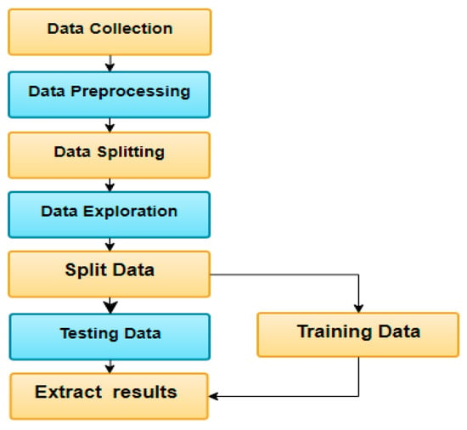

**Figure 1.** Methodology of processing data and model selection.

This section demonstrates three types of machine learning algorithms—long short-term memory (LSTM) and gated recurrent unit (GRU).

#### **Long Short-Term Memory (LSTM)**

For various learning issues involving sequential data, recurrent neural networks with long short-term memory (LSTM) have emerged as an effective and scalable approach. They are useful for capturing long-term temporal dependencies since they are generic and effective . The LSTM is an RNN-style architecture with gates that govern the flow of information between cells. The input and forget gate structures can modify information traveling along the cell state, with the ultimate output being a filtered version of the cell state based on context from the inputs . The LSTM design has been criticized for being ad hoc and for having a large number of components whose purpose is not immediately clear. As a result, it is unclear whether the LSTM is the best design, and it is likely that better ones exist . [**Figure 2**](https://www.mdpi.com/2673-2688/2/4/30#fig_body_display_ai-02-00030-f005) illustrates the structure of a LSTM algorithm.

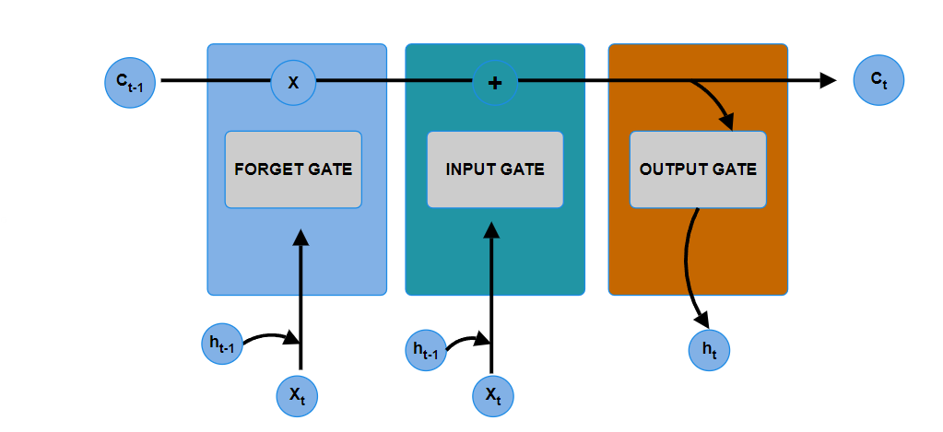

**Figure 2.** The structure of a long short-term memory (LSTM) algorithm.

The forward training process of the LSTM can be formulated with the following equations:

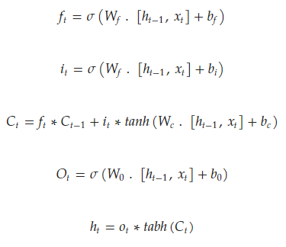

#### **Gated Recurrent Unit (GRU)**

Gated recurrent neural networks (Gated RNNs) have demonstrated their effectiveness in a variety of applications requiring sequential or temporal data .

**Results:**

The results obtained from long short-term memory (LSTM) and gated recurrent unit (GRU) algorithm. For each model, the results are illustrated in Tables. The RMSE of the GRU model is the lowest. Thus, GRU is more capable of predicting long-term dependencies as compared to LSTM . This is due to the dependency on past prices. Figures illustrate the comparisons between the actual and the predicted results. Simulation results from those models indicate that there are few occasions where the forecast result differs from the actual results.

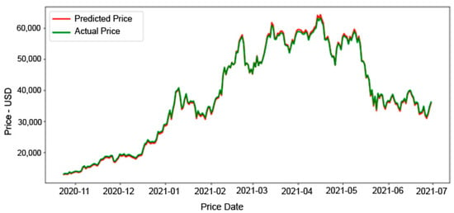

**Figure 5.** Actual and predicted price of BTC using the LSTM model

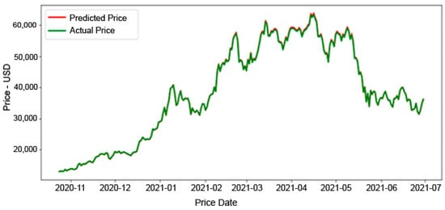

**Figure 6.** Actual and predicted price of BTC using the GRU model.

The results section presents the performance of two models (LSTM and GRU) in predicting the trends of the BTC cryptocurrency. The MAPE and RMSE values are used as metrics to assess the accuracy of the models.

The GRU model achieves the lowest MAPE value of 0.2454% and an RMSE of 174.129, indicating its superior ability to predict BTC trends compared to the LSTM model. The LSTM model is considered the second-best, with a MAPE of 1.1234% and an RMSE of 410.399.

Figure 4 visually compares the actual and LSTM-predicted BTC prices, showing a close resemblance between the predicted and actual values throughout the interval. Statistical analysis reveals small differences between the mean values of the predicted and actual prices, with a mean difference of 76.13 USD.

Figure 5 illustrates the comparison between the actual and GRU-predicted BTC prices. The graph demonstrates a nearly non-existent difference between the predicted and actual prices, particularly along the testing set. The mean difference between the mean values of the predicted and actual prices is 83.97 USD.

In contrast, Figure 6 reveals a larger difference between the actual and -predicted BTC prices compared to the LSTM and GRU models. The model exhibits a higher MAPE of 5.990% and an RMSE of 2927.006. The mean difference between the mean values of the predicted and actual prices is 1514.251 USD.

Overall, the results indicate that the GRU model outperforms the other models in accurately predicting BTC trends, with the LSTM model performing slightly worse but still achieving reasonable accuracy. The model shows a larger deviation from the actual prices.

## **Discussion:**

The proposed model in this research can be considered a reliable and acceptable model for cryptocurrency prediction.